Unsung Heroes

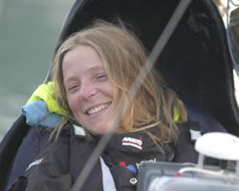
1. Hillary Lister
In 2005, Hilary Lister made history by sailing solo across the English Channel. Many people had done this before, but none were quadriplegic, which means not being able to use any part of your body from the neck down. Hilary was not born quadriplegic, but gradually lost the use of her body due to a disease. At first Hilary felt that she had lost everything, but when she first tried sailing, she felt that ‘it turned a light back on inside me’. She controls the boat through a computer, which is operated by her mouth. On 21 May 2009, Hilary Lister restarted her sail from Plymouth. By 14 August she had reached Bridlington on England’s east coast. She reached the end of her journey, Dover in Kent, on the evening of 31 August 2009, becoming the first disabled woman to sail solo around Britain.(The text is modified from https://www.teachingenglish.org.uk/sites/teacheng/files/WS1_Unsung_heroes.pdf)

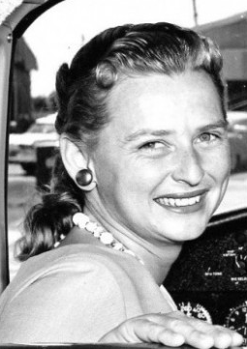
2. Jerrie Cobb
Geraldyn “Jerrie” Cobb fell in love with flying the first time she climbed into her father’s 1936 Waco bi-wing airplane at the age of 12. From there, she went on to be a record-setting aviator and the first woman to pass qualifying exams for astronaut training in 1960, but wasn’t allowed to fly in space because of her gender. Jerrie was denied her dream and rightful opportunity to be the first woman to fly in space because NASA deemed only men fit for space exploration. Here’s their convenient loophole: NASA required that astronauts have military jet test pilot experience, which automatically eliminated all women since women were not allowed to fly in the military. Setting her incredible disappointment aside, Jerrie decided to use her flying talent to serve the people of the Amazon jungle as a missionary pilot. For 35 years, she flew over the enormous uncharted jungle, bringing hope, seeds and help. For this work, she was honored by the governments of France, Brazil, Colombia, Peru and Ecuador, and was nominated for the Nobel Peace Prize in 1981. (The text is modified from http://www.womenyoushouldknow.net/first-woman-fly-space-meet-jerrie-cobb/)

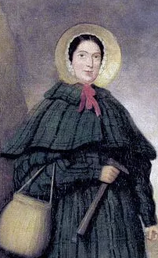
3. Mary Anning
Mary Anning was born in 1799, the daughter of a poor carpenter. Yet, she became one of the most important female scientists in history. Mary and her father, Richard, used to collect fossils to sell to tourists. A fossil is an animal or plant which turned to rock thousands of years ago, but, at that time, people did not really know what fossils were. Though her gender and social class made it difficult for her to fully participate in the scientific community of 19th-century Britain, she read as much scientific literature as she could get her hands on and went on to become a renowned fossil-hunter and dealer, often risking her life in the face of landslides and daunting cliffs. In 1812 Mary found the skeleton of a huge dinosaur, an ichthyosaur, which changed what people believed about the beginning of the world. Mary made many other important discoveries, but her work was not taken very seriously because she was a woman and uneducated.(The text is modified from https://www.teachingenglish.org.uk/sites/teacheng/files/WS1_Unsung_heroes.pdf)

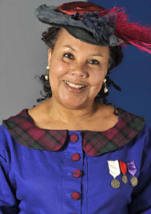
4. Mary Seacole
Mary Seacole was a Jamaican nurse who risked her life to treat wounded soldiers during the Crimean War. When Mary heard about the war in 1854, she immediately travelled to England, but found that the War Office refused her offer of help because she was black. Seacole was determined. She acquired knowledge of herbal medicine in the Caribbean. She travelled independently and set up her hotel in Kadikoi, Crimea and assisted battlefield wounded. She treated hundreds of soldiers there, and on the battlefield, for their wounds and also for diseases such as cholera, which took enormous bravery as she could easily have been killed or caught a fatal disease herself.She became extremely popular among service personnel who raised money for her when she faced destitution after the war.(The text is modified from https://www.teachingenglish.org.uk/sites/teacheng/files/WS1_Unsung_heroes.pdf)

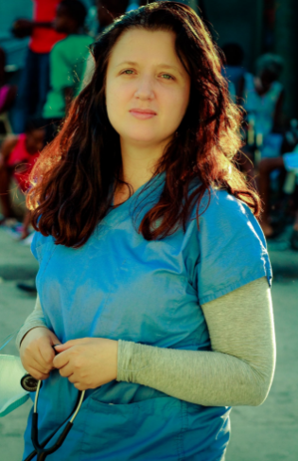
5. Megan Coffee
In 2010, Haiti was struck by a massive earthquake, which destroyed more than 250,000 homes. Dr Megan Coffee, an American expert in infectious diseases, set off to Haiti to help. She knew that diseases like tuberculosis (TB) would spread quickly in a place where people live without clean water or adequate shelter. Coffee didn’t have a hospital, so she set up a tent where people could come for treatment and advice. Six years later, she’s still in Haiti. She gave up her job, which was at a top university back in the United States, and she now does not receive a salary. Since she arrived, however, she has saved thousands of lives.(The text is retrieved from https://www.teachingenglish.org.uk/sites/teacheng/files/WS1_Unsung_heroes.pdf)
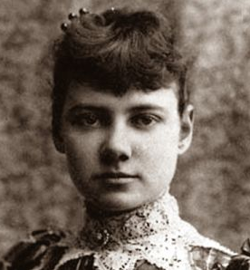
6. Nellie Bly
Nellie Bly was an American journalist known for her investigative and undercover reporting. One of Bly's earliest assignments at the paper was to author a piece detailing the experiences endured by patients of the infamous mental institution on Blackwell's Island (now Roosevelt Island) in New York City. In an effort to most accurately expose the conditions at the asylum, she pretended to be a mental patient in order to be committed to the facility, where she lived for 10 days.Bly's exposé, published in the World soon after her return to reality, was a massive success. The piece shed light on a number of disturbing conditions at the facility, including neglect and physical abuse, and ultimately spurred a large-scale investigation of the institution as well as much-needed improvements in health care.She earned acclaim in 1887 for her exposé. (The text is modified fromhttp://www.biography.com/people/nellie-bly-9216680#synopsis)

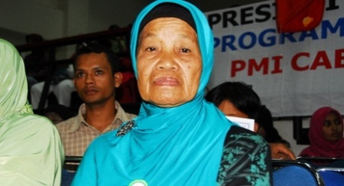
7. Nuraini
Despite having experienced profound tragedy, Red Cross Red Crescent volunteer Nuraini is determined to help others.After losing four children, 11 grandchildren and her home to the 2004 tsunami, 72-year-old Nuraini and her husband used their pension to build a kindergarten in Merduati village, Banda Aceh. “Children should begin their education early, which is why we started this kindergarten,” she says.When she is not running after the children at her school, Nuraini teaches cooking and traditional handicrafts to other women in her village as a community facilitator for a Psychological Support Programme (PSP) run by the American Red Cross and Indonesian Red Cross (Palang Merah Indonesia – PMI).Nuraini is one of 1,260 community and school PSP facilitators in the 137 communities and 154 schools in Banda Aceh, Aceh Besar and Aceh Jaya targeted by the programme. Nuraini and her fellow volunteer facilitators play a critical role in helping their communities to recover from the emotional toll of the tsunami. (The text is modified from http://www.ifrc.org/ar/news-and-media/news-stories/asia-pacific/indonesia/indonesia-banda-acehs-unsung-heroes/)

8. Yulisnawati
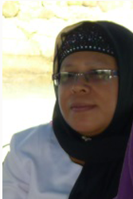
As a nurse and midwife, Yulisnawati, has worked in the Daik Health Center in the Lingga Subdistrict for over 20 years. In 2012, she was appointed as the focal person for lymphatic filariasis (LF), also known as elephantiasis, with the main responsibility of coordinating program staff, disease surveillance, and program implementation. Since becoming the focal person, Yulisnawati has worked very hard to coordinate, motivate and implement the LF program in her health center catchment area. Through continuous advocacy and hard work, she helped ensure a coverage rate of over 82% in the district’s first round of mass drug administration in an area that is logistically complicated by rough terrain and remote areas only accessible by boat.Yulisnawati’s motivation is driven by the five people with elephantiasis who live in the health center area. She is determined to cut LF transmission by ensuring that people take the required medicines in her supervised areas. To mobilize the community to come to the drug posts to receive medicine, Yulisnawati and her team distribute informational flyers, provide health education about LF transmission, and monitor for possible adverse events. She advocates for LF with the heads of villages and cadres (community health volunteers) to ensure that the communities are aware of the distribution period before it happens. Because of her long tenure in the district, Yulisnawati has developed close relationships with the community members, ensuring a level of trust that undoubtedly led to the high success of the mass drug distribution in her district.(The text is modified from https://www.neglecteddiseases.gov/newsroom/voices_from_the_field/ibu_indonesia.html)

